**Recognizing and Expressing Affect**

Presentation Summary

1

Affective computing refers to the calculation which arises from or deliberately influences emotions, and its main purpose is that computers are able to acquire the ability of recognizing, understanding and expressing affect. Affective computing will receive facial expression and signal from the change of people’s bodies by various sensor and then recognizing these signals by affective models, which is for understanding human emotions and make an appropriate response.

2 Research status of facial expression recognition

Facial expression recognition is the first step of affect recognition, which plays an important role of results of affect recognition. Nowadays, most of researches are under the circumstance of having clear and discernible faces.

There are two ways for us to locate and detect a face in a picture. One, we can regard a face as a whole to recognize. Two, we can detect some important characters of faces to recognize them.

Pantic and Rothkrantz viewed a face as a whole to recognize. They focused on the shapes and colors of faces. However, there are many disadvantages like they are not able to eliminate the interference of glasses or hairs on faces.

In 2001, Paul Viola held the view that people could apply AdaBoost algorithm to recognizing faces. AdaBoost algorithm would select some vital characters to construct classifiers and rapidly focused on some areas which are like faces. This method not only improved the speed of detection but also increased the detection rate. In addition, most of facial recognition systems are based on AdaBoost algorithm and then improve themselves.

2.2 feature extraction

Nowadays, the technology of facial recognition has improved a lot and it also meets needs of researches, so the researches of facial affect recognition now are mostly focus on how to make sure different emotions match with the different correct facial expression characters. In general, facial expressions are classified as surprise, fear, abhor, anger, happy and sad. Therefore, most of researches are focusing on facial feature extraction.

There are two ways of facial feature extraction: one of them is based on deformation and the other one is based on movement.

---models（markov，hmm）

This paper analyzes the nature of the facial expressions and gives a qualitative description of the corresponding facial expression space, and then proposes a new facial expression space model with the characters of both discrete affective space model and continuous affective space model.

We will focus on discrete affective space model.

Firstly, we will construct a three dimensional model based on fear, anger and happy, and any emotional status will match a certain point on the 3 dimensional space. In order to realize it, we will have to simplify that by discretizing. We can set that every basic emotion only have three intensity, which means that every dimensional will have 0, 0.5, and 1, three different values. Take happy for example, there are three strength, unhappy, a little happy and happy. Therefore, there are 27 discrete emotional status. We can define happy as a, anger as b, fear as c, so, there are a, b, c

|  |  |  |
| --- | --- | --- |
| No. | Status of Emotion | |
| 1 | Quiet(0,0,0) | |
| 2 | A little happy(0.5, 0, 0) | |
| 3 | A little angry(0, 0.5, 0) | |
| 4 | A little fear(0, 0, 0.5) | |
| 5 | A little happy, a little angry(0.5, 0.5, 0) | |
| 6 | A little angry, a little fear(0, 0.5, 0.5) | |
| 7 | A little happy, a little fear(0.5, 0, 0.5) | |
| 8 | A little happy, a little fear, a little angry(0.5, 0.5, 0.5) | |
| 9 | Happy(1, 0, 0) | |
| 10 | Angry(0, 1, 0) | |
| 11 | Fear(0, 0, 1) | |
| 12 |  | |
| 13 |  | |
| 14 |  | |
| 15 |  | |
| 16 |  | |
| 17 |  | |
| 18 |  | |
| 19 |  | |
| 20 |  | |
| 21 |  | |
| 22 |  | |
| 23 |  | |
| 24 |  | |
| 25 |  | |
| 26 |  | |
| 27 | Happy, fear, angry(1, 1, 1) | |
|  | |

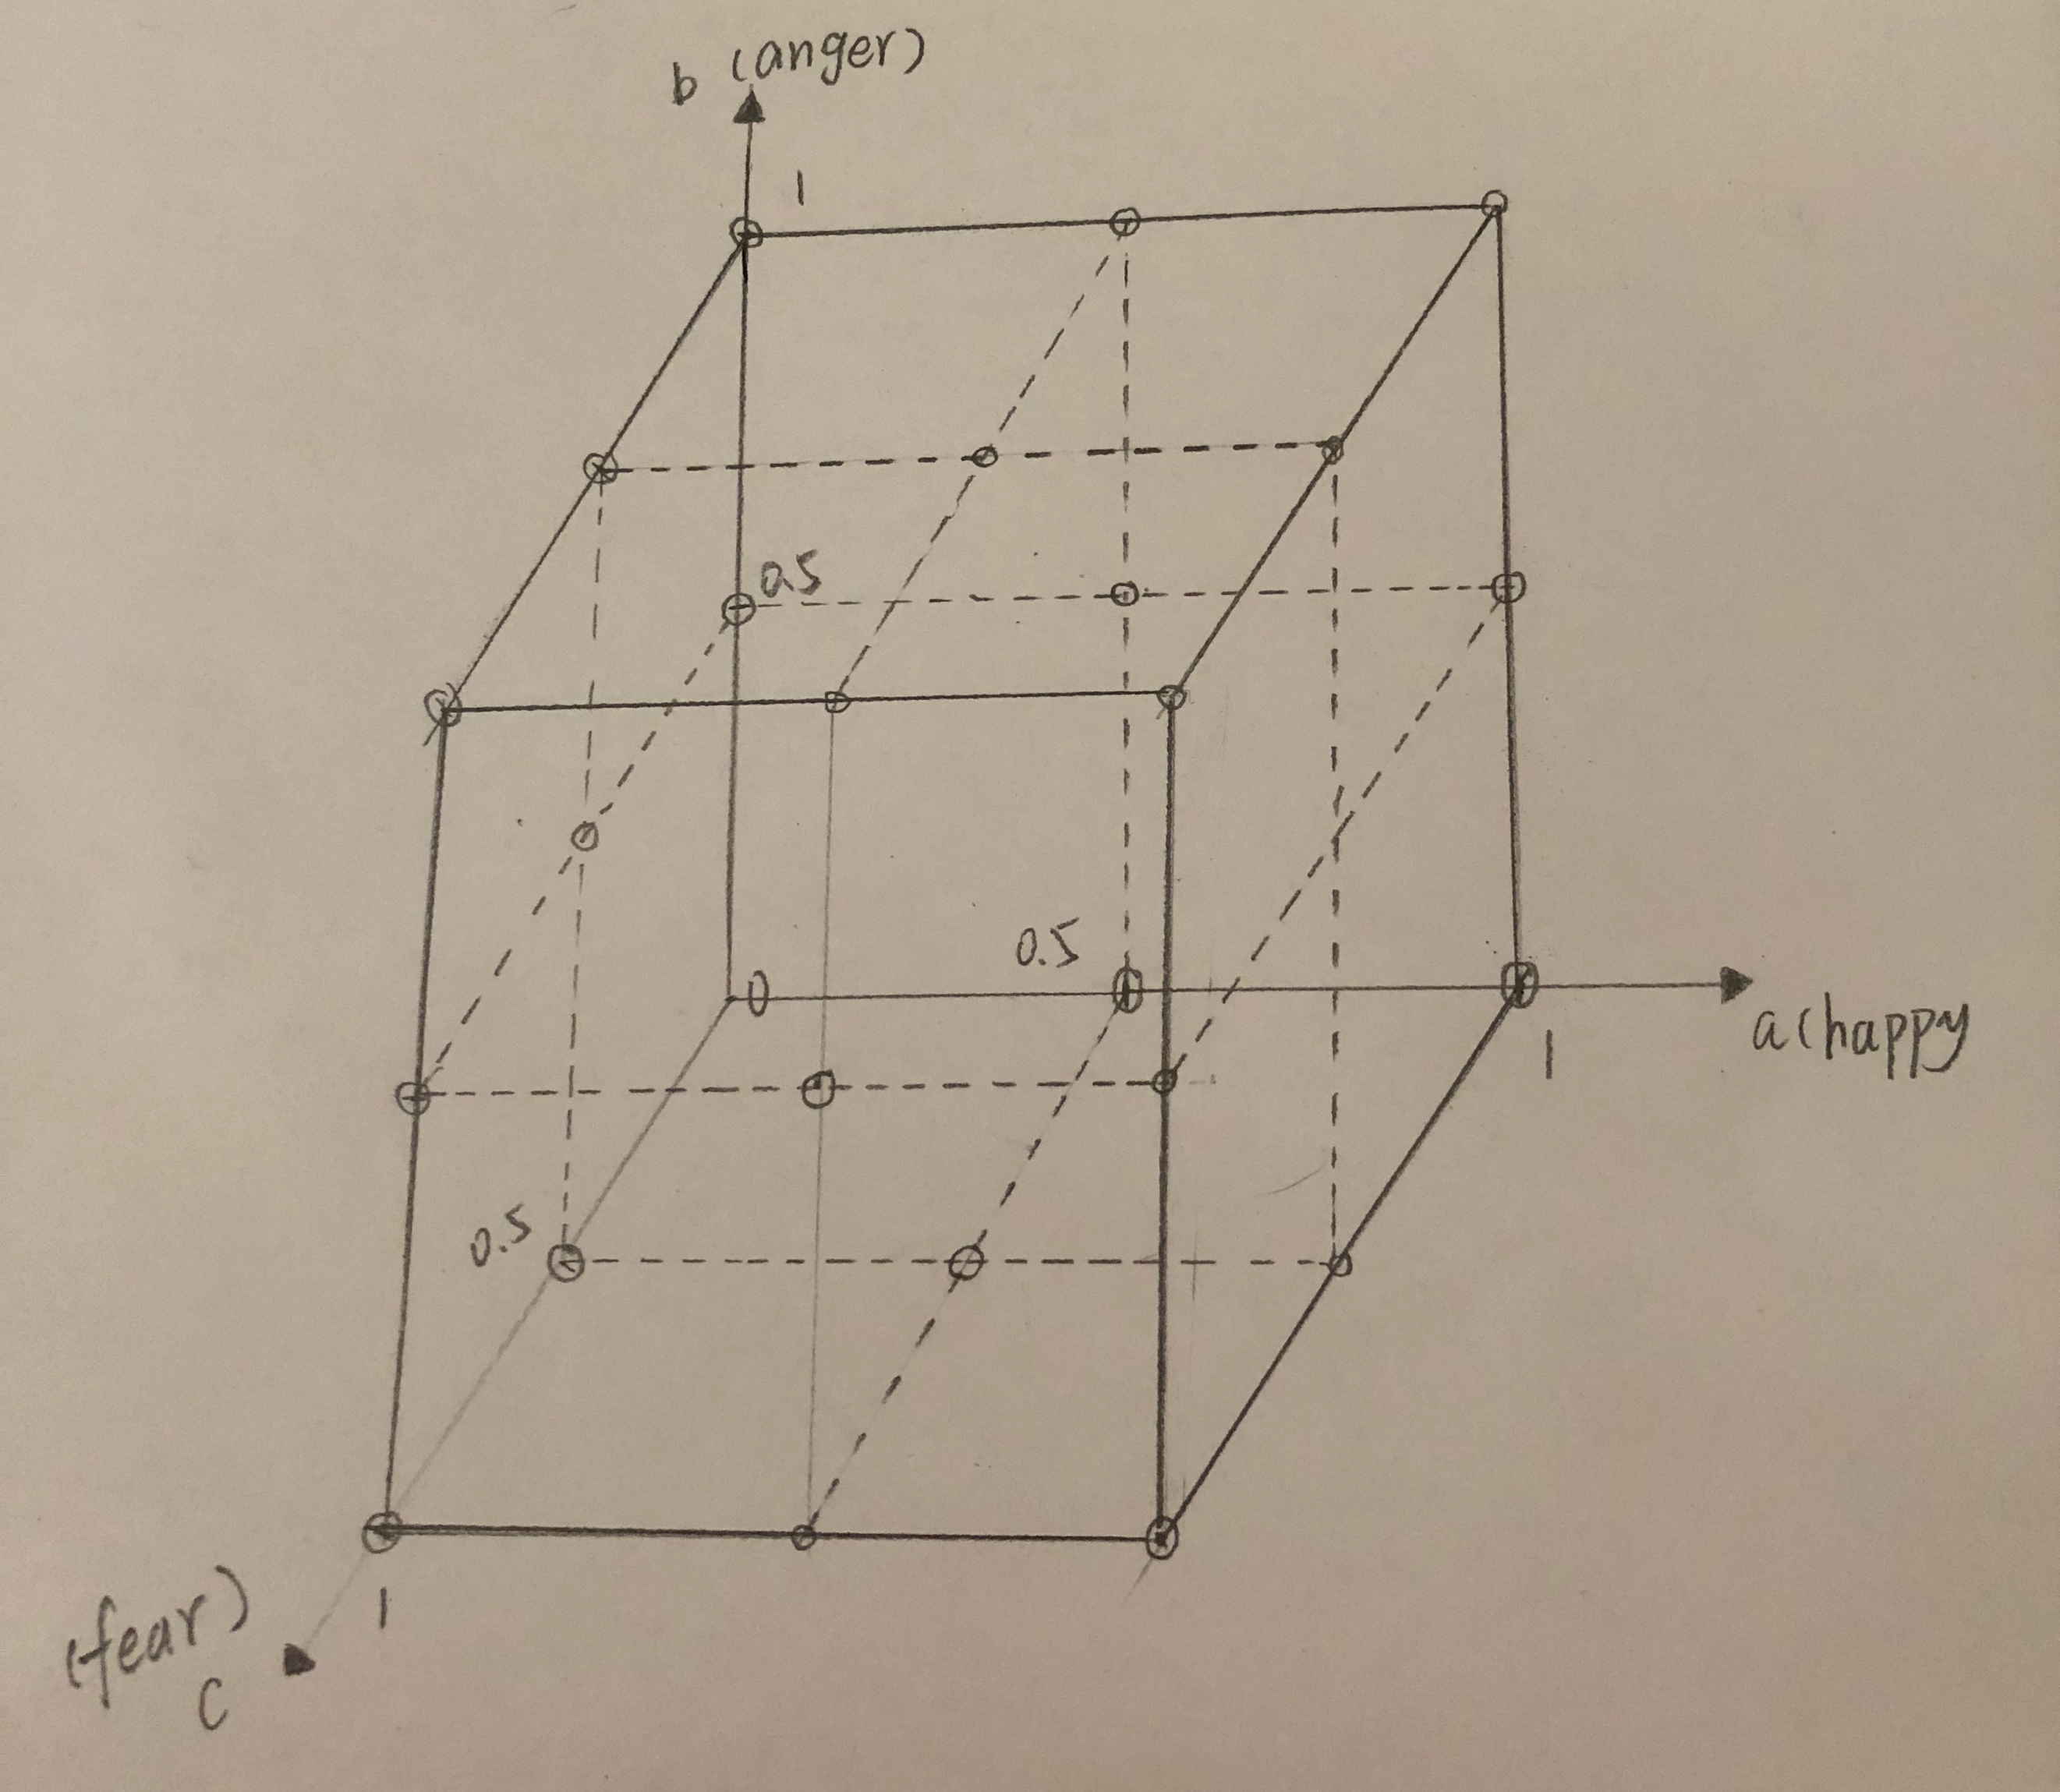

During the 27 points, origin of coordinates means quiet or no emotions. Some vertex also means quiet or some other emotion status. It is clear that this model is not completed.

When someone’s emotion go through this space, it is easy for us to find its statistical natures. This process we also call it Markov. Therefore we can use Markov model to describe how emotions change.

There is probability of changing emotion status in Markov model, so in this emotion model, there are 27 (i,j ) and they construct 27 dimensional Probability matrix .

=

(i,j ) is the probability of status to status. Additionally, there is a relationship among them:

We can conclude that if there are m emotions and there will be m dimensional emotional space, and for every emotion there are n levels, which means that there will be emotion status. Reagard l=, we can find that:

= and

In Markov model, the probability of change emotion will be influenced by many factors like personal characters, conscious stimulation. For example, under the positive simulation, the probability of changing a certain emotion to positive emotion will be larger than that of changing a certain emotion to negative emotion.

d-s theory

The D-S theory is a generalization of Bayesian inference, mainly by using the Bayesian conditional probability in the probability theory, and it needs to know the prior probability. While D-S evidence theory does not need to know a priori probability, and it can express "uncertainty" well, so it is widely used to deal with uncertain data.

Combine emotional space model with d-s evidence theory. Someone’s emotion will always stay at a certain point on this space and it will probably change to another point. But this process not only relate to its original position but also simulation from outer space. For example, it will be influenced by sounds, weather, pictures, smell and so on. Firstly, this model will capture outer simulation by sensor, and then D-S theory will be applied into it for combining outside emotion information, which finally will promote the transfer of emotion status and reach a new state of emotion.

---facial

Combine emotional space model with d-s evidence theory.

Firstly, this model will capture outer simulation by sensor, and then D-S theory will be applied into it for combining outside emotion information, which finally will promote the transfer of emotion status and reach a new state of emotion.

S = the strength of simulation from outside environment

P = basic credibility

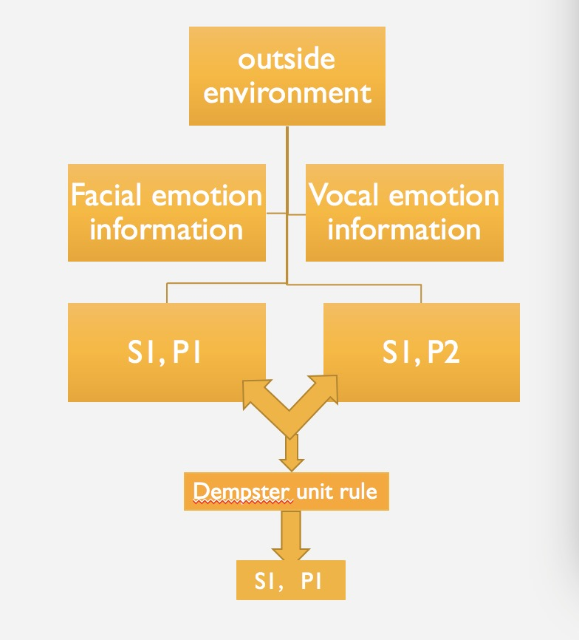

4 using CNN convolutional neural network to recognize facial expression

I will design a specific experiment on how to recognize facial expression

First of all, I download some dataset from the website, and some of them are as training data and others are testing data. (For convenience, we used 3000 pictures as training data and 5000 pictures as testing dataset )

There are five steps for us to do:

1. we can read the data downloaded from website.
2. We will get and save the labels and pictures, setting up the batch for providing data when training network.
3. Construct CNN convolutional neural network.
4. Train it.
5. Check it and calculate the accuracy rates.

----sound

---body